Team Name: OwlVision

Product Name: OwlVision

Team Members:

Owner: Darek Dziamalek

Scrum Master: Austen Stone

Scrums: Zachary Goddard

Michael Sherman

Dewayne Tulloch

Purpose

The purpose of OwlVision is to create an app that allows students and administrators to have easy access to information about the Florida Atlantic University Campus. This information includes events, study groups, and issues that are around the campus. Students and administrators will be able to post comments about the various issues, events and study groups on the campus. Users will also be able to quickly set up a profile that allows them to personalize the app. This app allows users to connect in an effective way because it also works on mobile platforms. OwlVision will enhance the college experience of every student and administrator.

Motivation

Our drive to build this application comes from the desire to connect students across campus with one easy application.  We wish to bring students together by allowing them to go to events with friends, connect a class and improve their grades with a study group, or even report issues to improve the campus for everyone. Our true desire is to improve the college experience of everyone who uses OwlVision, by providing them information they need in an effective way.

Functionalities

Students and administrators will be able to post, edit, and browse; events, study groups, and issues. Both students and administrators can register. Students can set up a profile to track activity. Administrators will be able to monitor issues and declare when they are resolved. The dashboard will display the user's profile: including issues, events, and study groups created by the user. The dashboard also helps to prevent users from getting lost in navigation. There is a help section that will provide answers to questions users may have about the operation of our product. The navigation of the website will be simple so that all users can effectively use the app.

Target Audience

Our target audience are the students and administrators of FAU. Our app was built to be accessible to everyone in our target audience.

Contributions

Darek Dziamalek: Worked on the backend of the project, including the databases and servers. Also worked on the coding for the frontend of the project.

Austen Stone: Created the visual design for our project. Also worked on the coding for the frontend of the project.

Zachary Goddard: Worked on the coding for the frontend of the project and documents for the project.

Michael Sherman: Worked on the coding for the frontend of the project and documents for the project.

Dewayne Tulloch: Worked on the coding for the frontend of the project and documents for the project.

Each team member contributed their part to the project. Each team member will receive 20/20 points.

Screenshots of GUI mockup

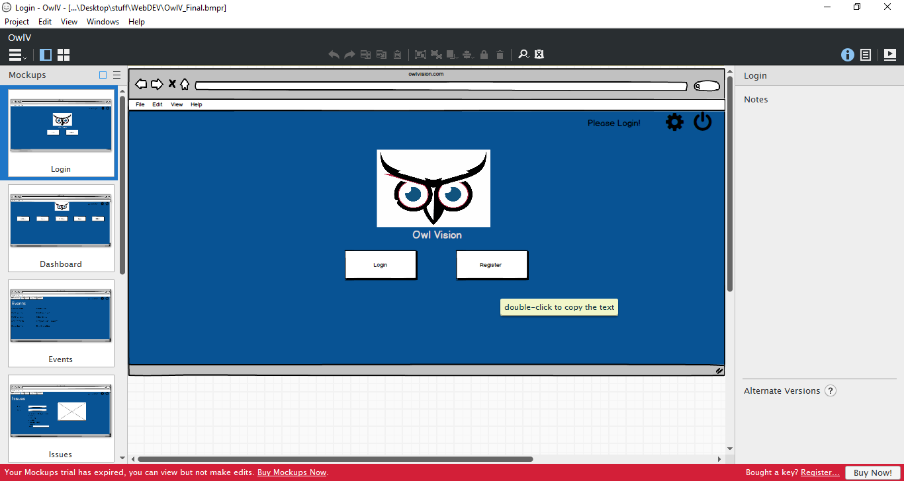

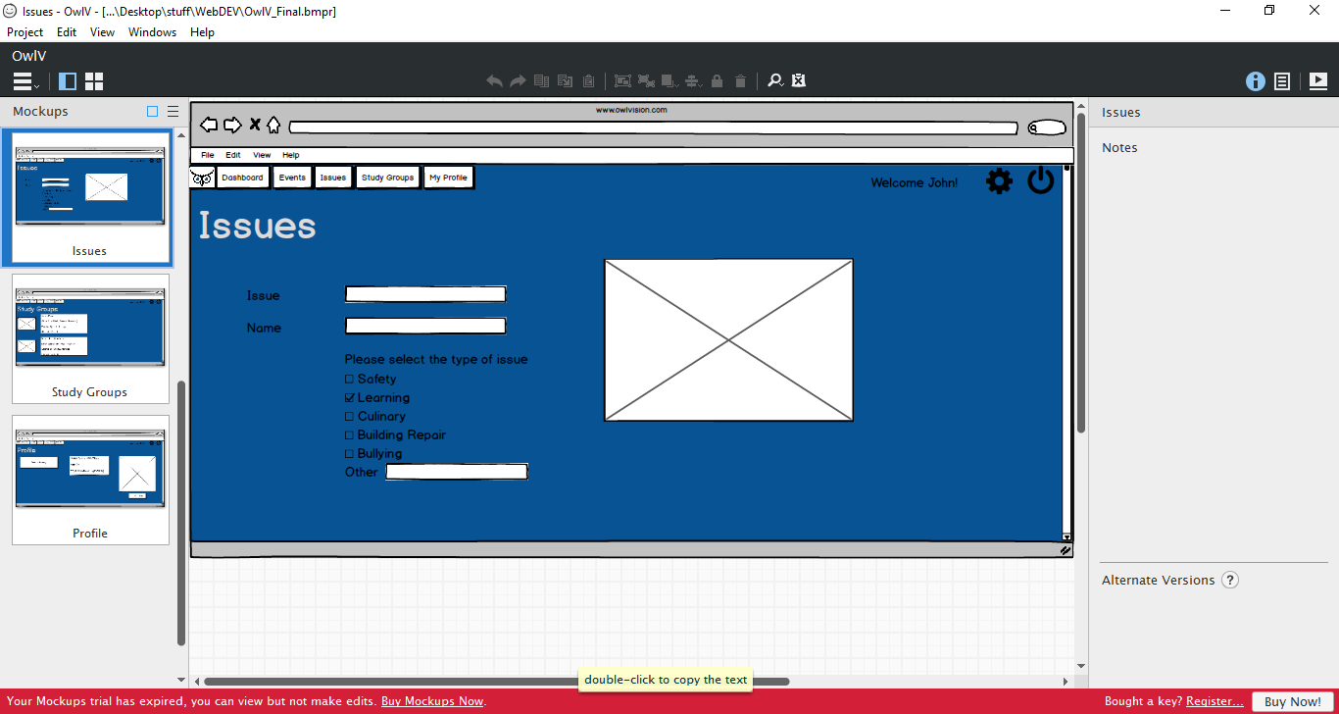

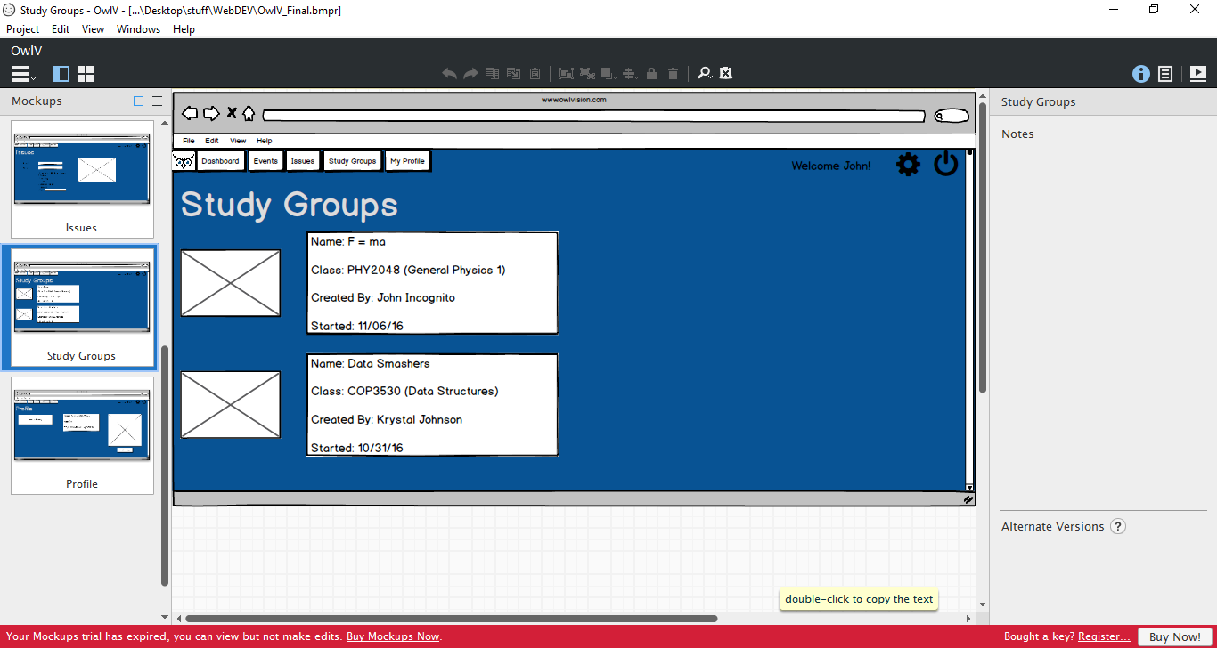

Screenshots of Scrum Project Space

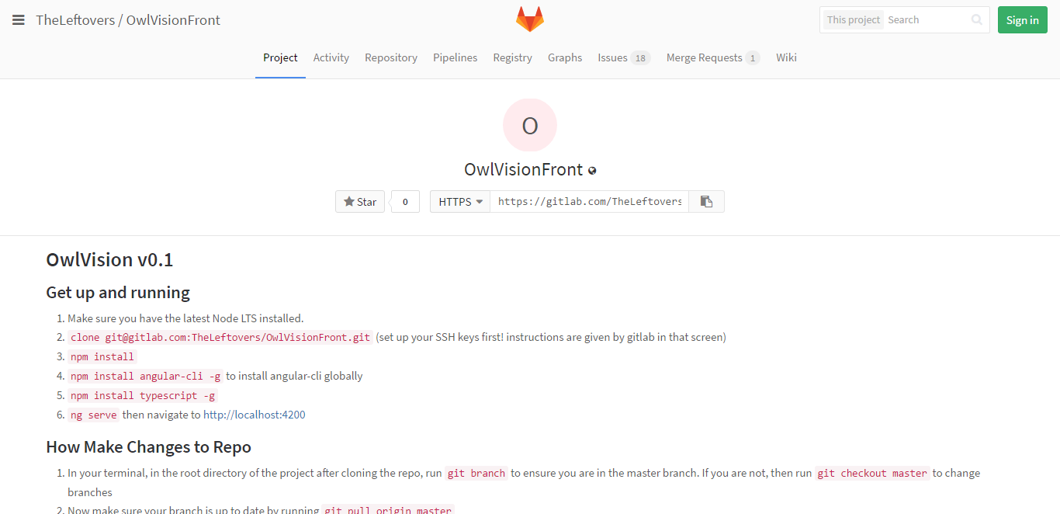

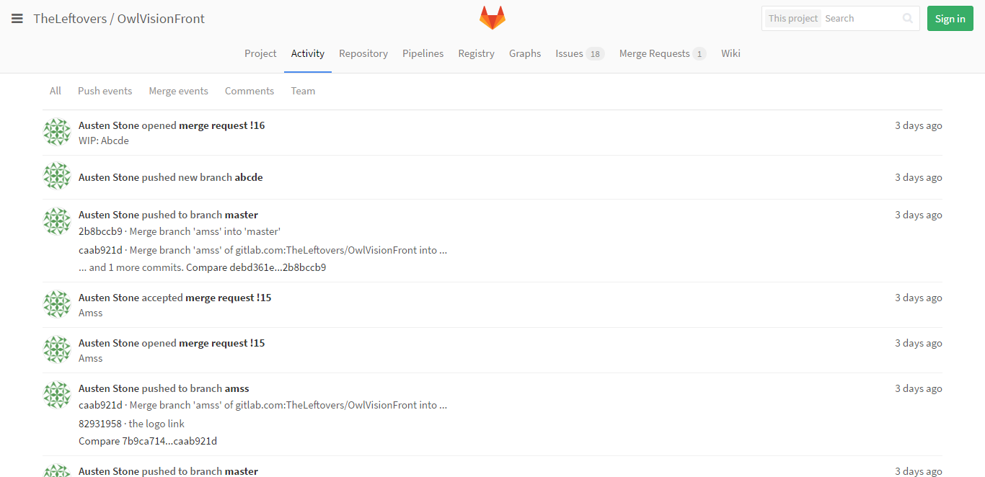

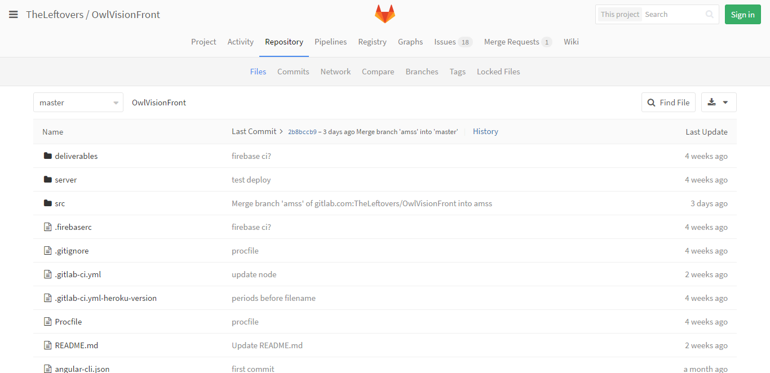

Screenshots of Final Product

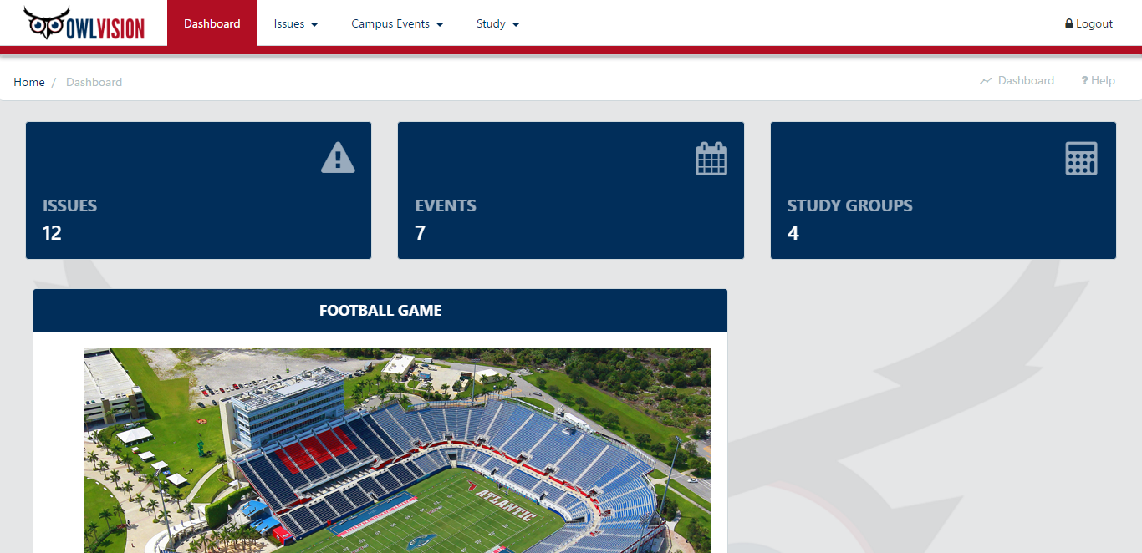

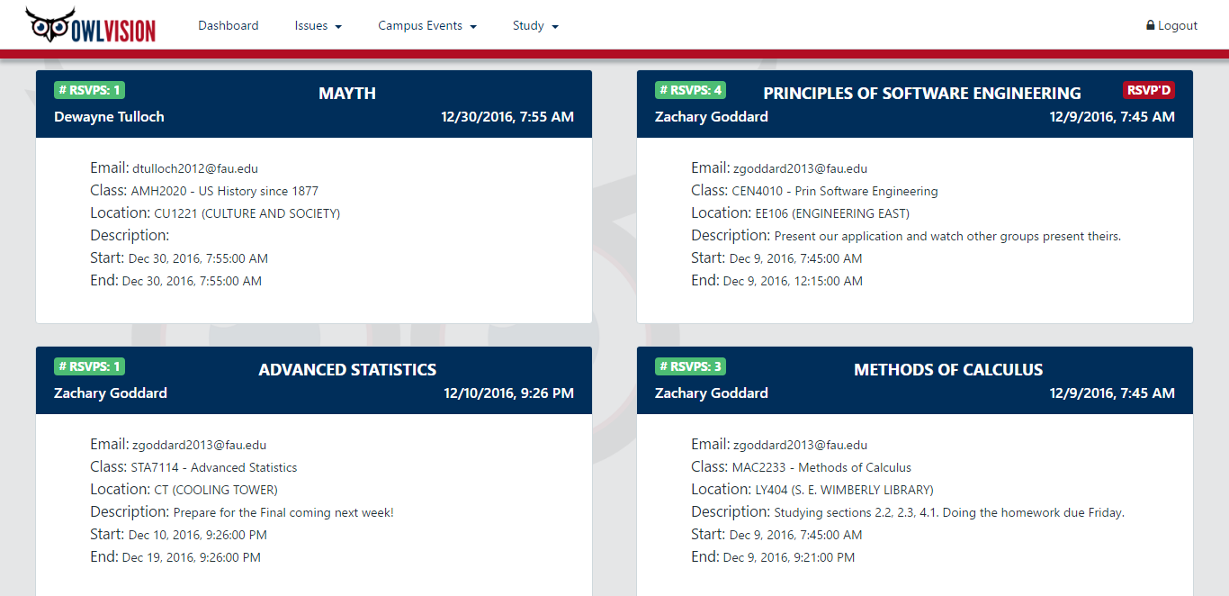

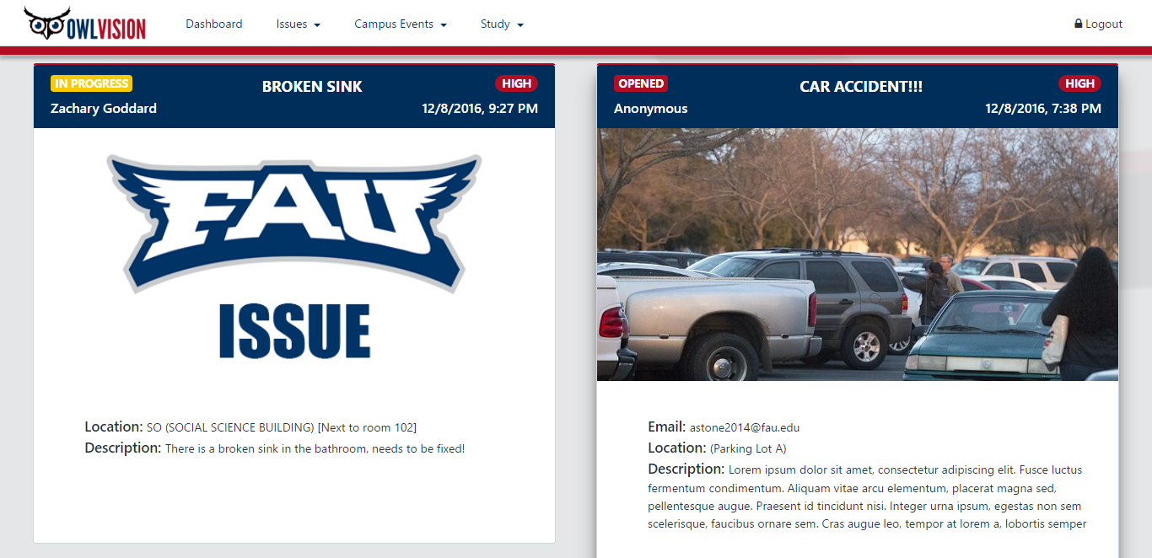

Features

Finished features include:

* A dashboard displaying the user's profile: including issues, events, and study groups created by the user.
* The ability to post, edit, and browse; events, study groups, and issues.
* Authentication through google.
* A functioning help section.
* The ability to browse study groups based on the classes the user is taking.
* The ability to upload pictures.
* Firebase integration which provides: a real-time database, hosting, storage, and user management.
* Fully compatible with mobile devices.

We would have liked to add the following features, but we did not have enough time:

* A customizable profile page.
* Live chat messaging.
* A like/dislike comment system.
* Notifications.
* A search engine for events, study groups, and issues.

Knowledge gained

We learned many things through this endeavor. We learned how to effectively communicate with a team through the application, Slack. We learned organizing team member assignments through apps like GitLab and Trello. We learned how to effectively brainstorming ideas and express them using the Trello app. We learned various Git commands that allowed us to take full advantage of GitLab. Now we can make changes to the application locally and push to a repository, so everyone on the team sees and can build on those changes. The skills that we learned today will be applicable to us in the future, when we are faced with another team project.